

The Problem

IBM Developer

SKILLS NETWORK

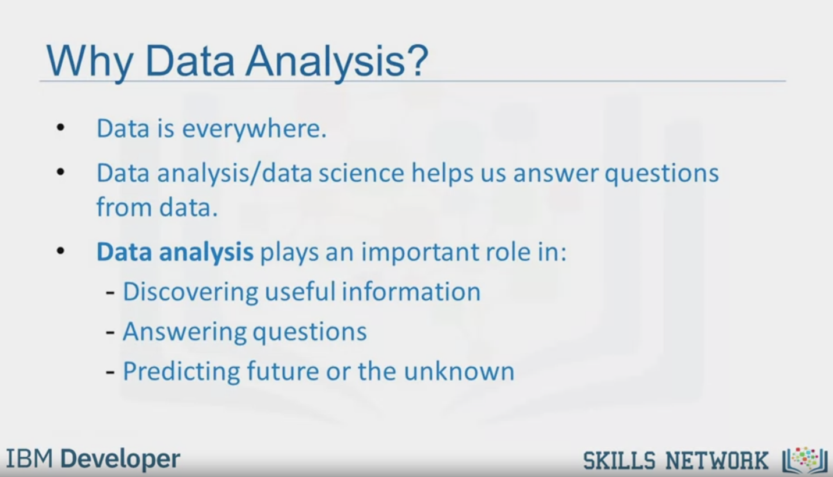

Why Data Analysis?

Data is everywhere.

Data analysis/data science helps us answer questions

from data.

Data analysis plays an important role in:

- Discovering useful information

- Answering questions

- Predicting future or the unknown

IBM Developer

SKILLS NETWORK



Tom wants to sell his car

Tom

How much

money should he

sell his car for?

The price he sets should not be too high,

but not too low either.

IBM Developer

SKILLS NETWORK

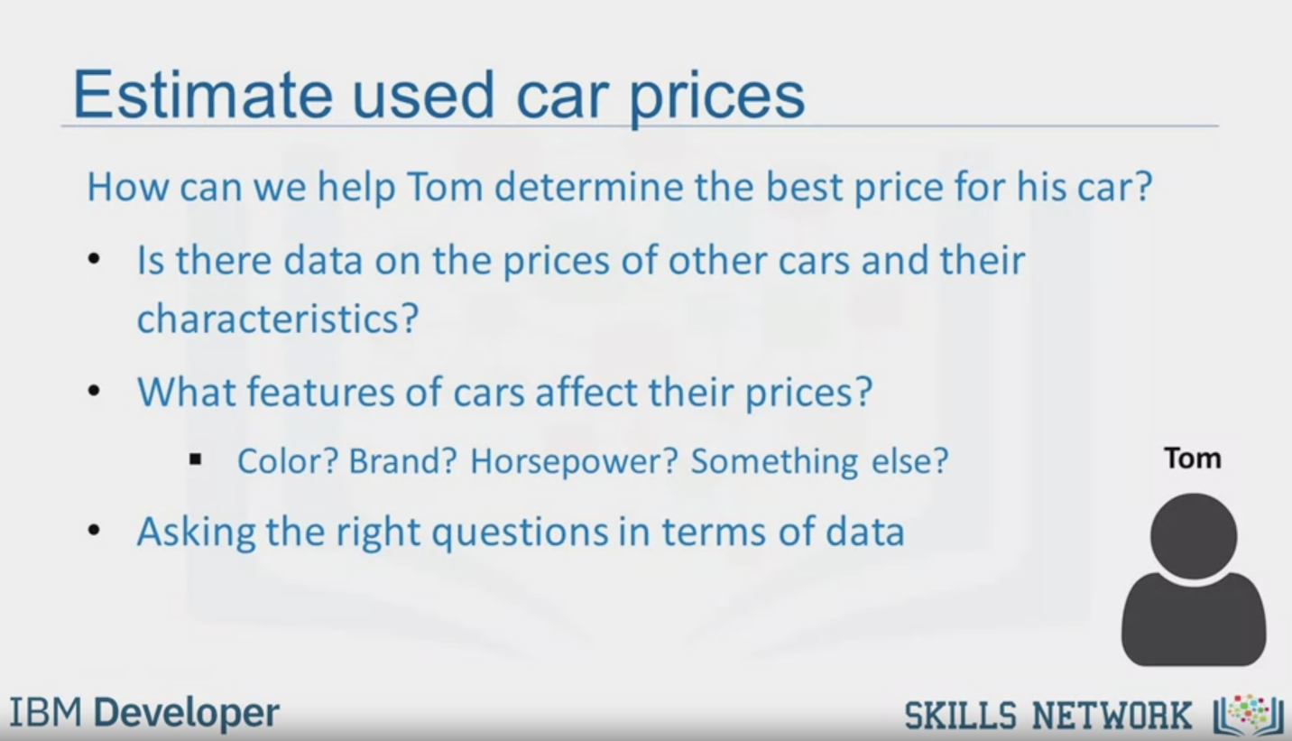

Estimate used car prices

How can we help Tom determine the best price for his car?

Is there data on the prices of other cars and their

characteristics?

• What features of cars affect their prices?

- Color? Brand? Horsepower? Something else?

• Asking the right questions in terms of data

Tom

IBM Developer

SKILLS NETWORK

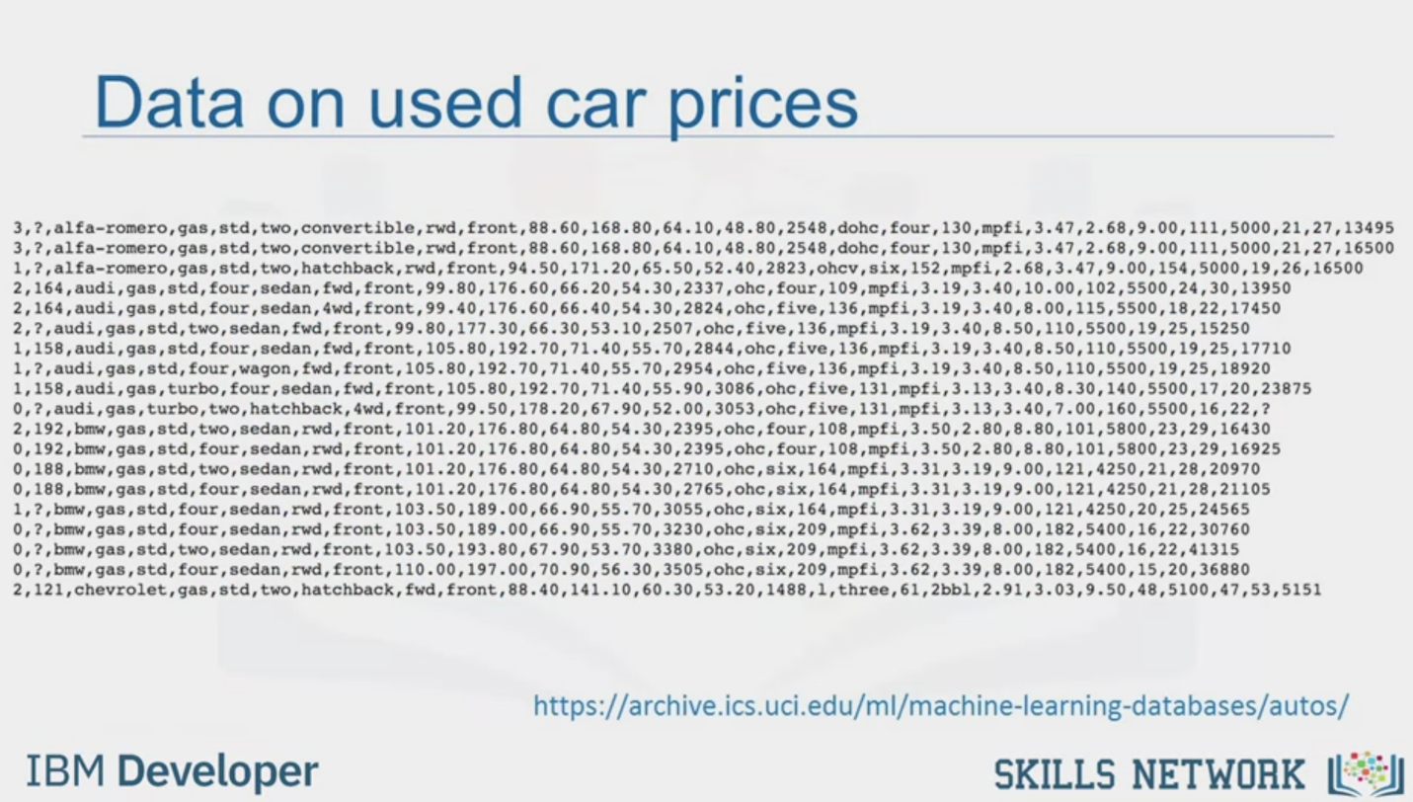

Data on used car prices

<https://archive.ics.uci.edu/ml/machine-learning-databases/autos/>

IBM Developer

SKILLS NETWORK



SKILLS NETWORK

IBM Developer

In this video, we'll be talking about data analysis and

the scenario in which we'll be playing the data analyst or data scientist.

But before we begin, talking about the problem, used car prices,

we should first understand the importance of data analysis.

As you know, data is collected everywhere around us.

Whether it's collected manually by scientists or collected digitally,

every time you click on a website, or your mobile device.

But data does not mean information.

Data analysis and, in essence,data science, helps

us unlock the information and insights from raw data to answer our questions.

So data analysis plays an important role by helping us to discover useful

information from the data, answer questions, and even predict the future or

the unknown.

So let's begin with our scenario.

Let's say we have a friend named Tom.

And Tom wants to sell his car.

But the problem is he doesn't know how much he should sell his car for.

Tom wants to sell his car for as much as he can.

But he also wants to set the price reasonably, so

someone would want to purchase it.

So the price he sets should represent the value of the car.

How can we help Tom determine the best price for his car?

Let's think like data scientists and clearly define some of his problems.

For example, is there data on the prices of other cars and their characteristics?

What features of cars affect their prices?

Color?

Brand?

Does horsepower also effect the selling price, or perhaps something else?

As a data analyst or

data scientist, these are some of the questions we can start thinking about.

To answer these questions, we're going to need some data.

In the next videos, we'll be going into how to understand the data, how to import

it into Python, and how to begin looking into some basic insights from the data.